Lấy bài viết

<?php
$args = [
'post_type' => 'post',
'post_status' => 'publish',
'posts_per_page'=> 5,
];
$the_query = new WP_Query( $args );
?>
<?php global $wp_query; $wp_query->in_the_loop = true; ?>
<?php
// The Loop
while ( $the_query->have_posts() ) : $the_query->the_post();
?>
<li class="c-listpost__item">
<div class="c-listpost__info">
<span class="datepost"><?= get_the_date('Y/m/d') ?></span>
<?php
$cats = get_the_category(get_the_ID());
foreach ($cats as $cat) {
?>
<span class="cat">
<i class="c-dotcat" style="background:<?php echo get_the_category()[0]->description ?>;"></i>
<a href="<?= get_category_link($cat->cat_ID) ?>"><?= $cat->name ?></a>
</span>
<?php } ?>
</div>
<h3 class="titlepost"><a href="<?= get_the_permalink() ?>"><?php the_title(); ?></a></h3>
</li>
<?php endwhile; wp_reset_postdata(); ?>

lấy ds category khi ta click vào 1 category nào đó
<?php
var_dump(get_category(get_query_var('cat')));
$category = get_category(get_query_var('cat'));
$args = [
'post_type' => 'post',
'post_status' => 'publish',
'posts_per_page'=> 5,
'cat' => $category->cat_ID,
];
$the_query = new WP_Query( $args );
?>
<?php global $wp_query; $wp_query->in_the_loop = true; ?>
<?php
// The Loop
while ( $the_query->have_posts() ) : $the_query->the_post();
?>
<li class="c-listpost__item">
<div class="c-listpost__info">
<span class="datepost"><?= get_the_date() ?></span>
<?php
$cats = get_the_category(get_the_ID());
foreach ($cats as $cat) {
?>
<span class="cat">
<i class="c-dotcat" style="background:<?php echo get_the_category()[0]->description ?>;"></i>
<a href="<?= get_category_link($cat->cat_ID) ?>"><?= $cat->name ?></a>
</span>
<?php } ?>
</div>
<h3 class="titlepost"><a href="<?= get_the_permalink() ?>"><?php the_title(); ?></a></h3>
</li>
<?php endwhile; wp_reset_postdata(); ?>

lấy ảnh đại diện
dong này để vào nơi cần get anh đại diện
<?php echo get_the_post_thumbnail( $post_id, 'home-thumb', array( 'class' =>'thumnail') ); ?>

đẻ vào function
// add image
add_theme_support( 'post-thumbnails' );

// get first image
function catch_that_image() {
global $post, $posts;
$first_img = '';
ob_start();
ob_end_clean();
$output = preg_match_all('/<img.+src=[\'"]([^\'"]+)[\'"].*>/i', $post->post_content, $matches);
$first_img = $matches [1] [0];

if(empty($first_img)){ //Defines a default image
$first_img = "/images/default.jpg"; //Duong dan anh mac dinh khi khong tim duoc anh dai dien
}
return $first_img;
}
// Edit size image
add_action( 'after_setup_theme', 'wpdocs_theme_setup' );
function wpdocs_theme_setup() {
add_image_size( 'home-thumb', 1050, 400);
}

/* Custom Post Type services */
function create_posttype() {
register_post_type(
'services',
array(
'label' => 'services',
'labels' => array(
'all_items' => 'services all',
'add_new' => 'Add new',
'add_new_item' => 'Add new service',
'edit_item' => 'Edit',
'new_item' => 'new item',
'view_item' => 'view',
'search_items' => 'search',
'not_found' => 'not found',
'not_found_in_trash' => 'not found in trash',
),
'public' => true,
'has_archive' => true,
'supports' => [ 'title', 'thumbnail', 'editor' ],
));
}
add_action( 'init', 'create_posttype' );

// add image hiển thị ảnh đại diện trong bài post
add_theme_support( 'post-thumbnails' );

// create breadcrumbs
function get_breadcrumb() {
echo '<a href="'.home_url().'" rel="nofollow">Home</a>';
if (is_category() || is_single()) {
echo "&nbsp;&nbsp;&#62;&nbsp;&nbsp;";
the_category(' &bull; ');
if (is_single()) {
echo " &nbsp;&nbsp;&#62;&nbsp;&nbsp; ";
the_title();
}
} elseif (is_page()) {
echo "&nbsp;&nbsp;&#62;&nbsp;&nbsp;";
echo the_title();
} elseif (is_search()) {
echo "&nbsp;&nbsp;&#62;&nbsp;&nbsp;Search Results for... ";
echo '"<em>';
echo the_search_query();
echo '</em>"';
}
}

lấy ảnh từ bài post được click

<img src="<?php echo get_the_post_thumbnail_url('','full'); ?>" alt="<?php the_title(); ?>">

trở lại trang trước đó
onclick="history.back(-1)"

Sử dụng cho form in form ra từ plugin WM WP
​
<?php echo do_shortcode('[mwform_formkey key="266"]')?>

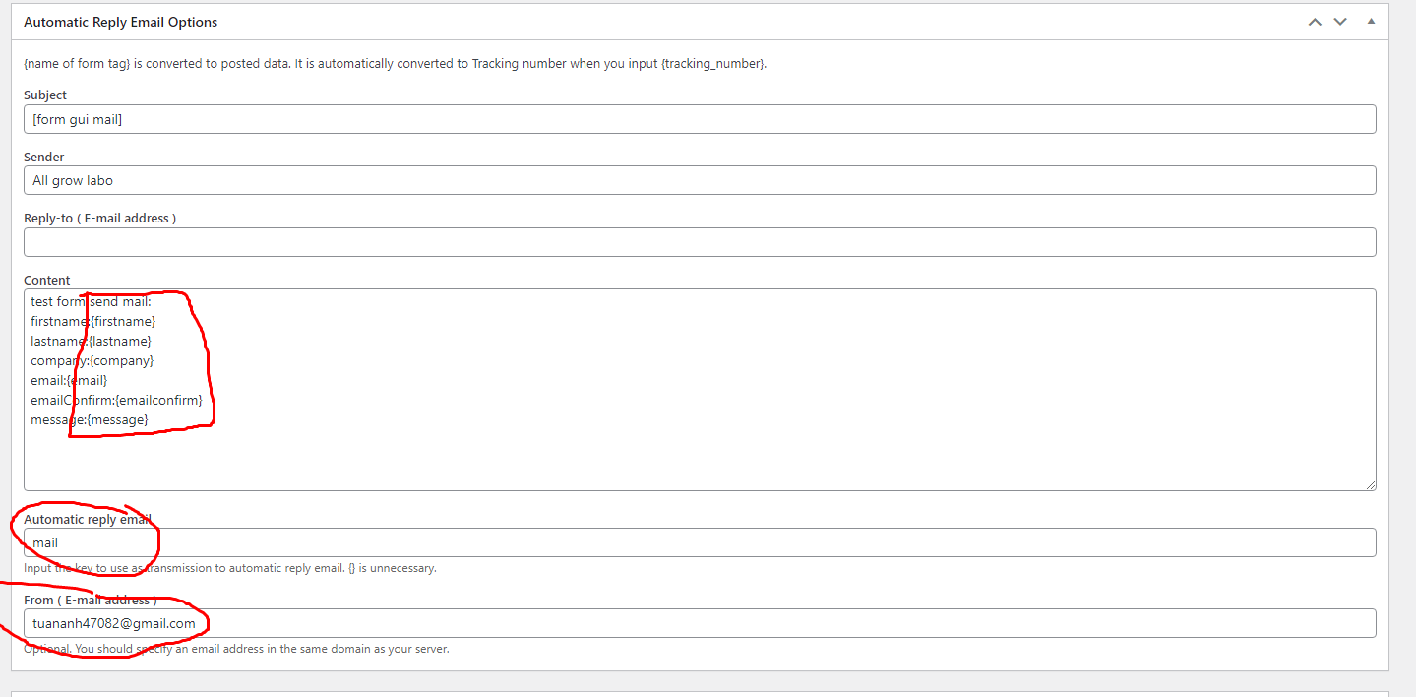

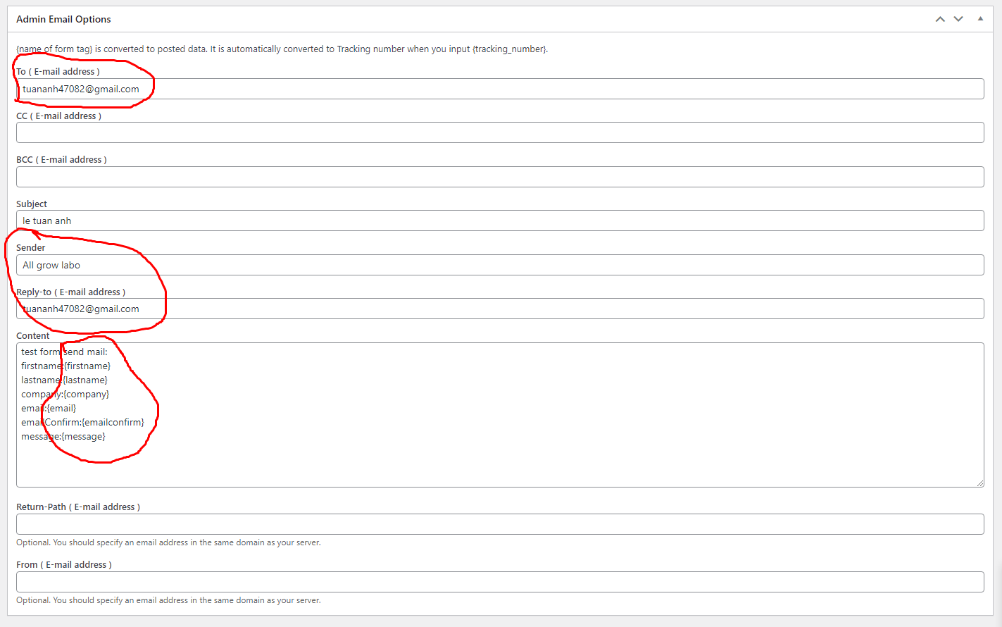
form sử dụng button comfirm rồi tới submit and back button

lấy bài viết custom post type services
<?php
$paged = (get_query_var('paged')) ? get_query_var('paged') : 1;
$args = [
'post_type' => 'services',
'post_status' => 'publish',
'posts_per_page'=> 12,
'paged' => $paged

];
$the_query = new WP_Query( $args );
?>
<?php global $wp_query; $wp_query->in_the_loop = true; ?>
<?php
while ( $the_query->have_posts() ) : $the_query->the_post();
?>
<li class="c-column__item"><a href="<?php the_permalink() ?>">
<?php echo get_the_post_thumbnail( $post_id, 'home-thumb', array( 'class' =>'thumnail') ); ?>
<p><?php the_title(); ?></p></a>
</li>
<?php endwhile; wp_reset_postdata(); ?>

lấy ds category custom post type
<?php
$terms = get_terms(
array(
'taxonomy' => 'services_category', // Custom Post Type Taxonomy Slug
'hide_empty' => false,
'order' => 'asc'
)
);
$i = 2;
foreach ($terms as $term) {
?>
<div class="c-w240">
<label><input class="chkbutton" type="checkbox" name="" value="<?= $i ?>" <?php if($i == 2){echo "checked";}?>><?= $term->name ?></label>
</div>
<?php
$i++;
}
?>

